Expert Lecture
Academic Year 2024-2025
S.No | Name of the Resource person | Designation and organization | Date organized | Topic covered
1 | Er. Raj kumar | M.D Dhrumaturu Consultants Pvt. Ltd | 27-07-2024 | Advanced concrete materials in association with ICI
2 | 1)Dr. P.Ammani  2) Dr. Ravindranath choudsry K | Nicmarkc University | 04-12-2024 | Recent technological advancements in CRIP sector and Project communications challenges and Technomanagical opportunities
3 | Ms. Rajini kandarpa |  | 29-01-2025 | Career development
4 | Dr.Y.Jashnavi |  | 05-02-2025 | The future of smart transportation
5 | D.Ramchander | Sri Ramachandra developers pvt. ltd | 15-02-2025 | Construction practices in Field
6 | 1) Mr Soma Venkat  2) Mr. J. Narendra |  | 24-02-2025 | GGBS for strong durable sustainable and green concrete construction
7 | Dr. K.Praveen | Reva University | 02-05-2025 | Construction Materials and their role in Sustainability

Faculty Development Program

Academic Year 2024-2025
S. No | Name of the Resource person | Organization By | Date organized | Topic covered
1 | Ms. P. Supriya | SkillDzire in Collaboration with AICTE | 1 month (June- July 2024) | Revit Architecture
2 | Ms. V. Navaneetha | Dr. D. Y. Patil Institute of Technology, Pimpiri, Pune | 5- Day (02.09.2024 06.09.2024) | Coastal Engineering: Comprehensive Insights for Onsite solutions
3 | Dr. R. Prasanna Kumar | GCET | 5-Day (30.07.2024 to 03.08.2024) | Construction Project management and Advances in Construction materials towards achieving Sustainability
4 | Dr. V. V. Praveen Kumar | GCET | 5-Day (30.07.2024 to 03.08.2024) | Construction Project management and Advances in Construction materials towards achieving Sustainability GCET
5 | Mr. V. Goutham | GCET | 5-Day (30.07.2024 to 03.08.2024) | Construction Project management and Advances in Construction materials towards achieving Sustainability
6 | Ms. P. Supriya | GCET | 5-Day (30.07.2024 to 03.08.2024) | Construction Project management and Advances in Construction materials towards achieving Sustainability GCET
7 | Mr. G. Raju | GCET | 5-Day (30.07.2024 to 03.08.2024) | Construction Project management and Advances in Construction materials towards achieving Sustainability
8 | Mr. G. Sampath Kumar | GCET | 5-Day (30.07.2024 to 03.08.2024) | Construction Project management and Advances in Construction materials towards achieving Sustainability GCET
9 | Ms. V. Navaneetha | GCET | 5-Day (30.07.2024 to 03.08.2024) | Construction Project management and Advances in Construction materials towards achieving Sustainability
10 | Mr. M. Srujan Kumar | GCET | 5-Day (30.07.2024 to 03.08.2024) | Construction Project management and Advances in Construction materials towards achieving Sustainability GCET
11 | Mr. N. Srikanth | GCET | 5-Day (30.07.2024 to 03.08.2024) | Construction Project management and Advances in Construction materials towards achieving Sustainability
12 | Mr. D. Varun Kumar | GCET | 5-Day (30.07.2024 to 03.08.2024) | Construction Project management and Advances in Construction materials towards achieving Sustainability GCET
13 | G.Vimala | GCET | 5-Day (30.07.2024 to 03.08.2024) | Construction Project management and Advances in Construction materials towards achieving Sustainability GCET

Training Programme

Academic Year 2024-2025
S. No | Name of the Resource person | Designation and Organization | Date organized | Topic covered | Activity
1 | 1. B. Santhosh, 2. S. Sai Mrudula, 3. B. Renuka | Trianer, CANTER CADD | 17-08-2024, 24-08-2024  31-08-2024, 7-09-2024  14-09-2024, 21-09-2024  28-09-2024, 5-10-2024  19-10-2024, 23-10-2024 | “Career opportunities for students of Civil Engineering”  (Through extensive use of 'BIM Arch.' as a design tool) | Software Training Program
2 | 1. B. Santhosh, 2. S. Sai Mrudula, 3. B. Renuka | Trianer, CANTER CADD | 08-02-2025, 22-02-2025,  1-03-2025, 8-03-2025,  22-03-2025, 29-03-2025, 26-04-2025, 03-05-2025, 06-06-2025, 09-06-2025 | “Career opportunities for students of Civil Engineering”  (Through extensive use of 'Revit Arch.' as a design tool) | Software Training Program

Paper Publications
Academic Year : 2024-25
S No | Name of the faculty | Title of the paper | Journal | Year
1 | Dr. V. V. Praveen Kumar, | A systematic analysis of binary blend cement concrete infused with lime sludge and fly ash | Chemistry of Inorganic Materials Elsevier | September 2024,
2 | Mr. G. Raju | Geogrid Technology: Boosting Subgrade Strength for Sustainable Infrastructure | Journal of Engineering and Technology Management Volume 74. | December 2024,
3 | Mr. G. Raju | Laboratory Evaluation of Industrial Waste Utilization In Pavement Construction | Journal of Civil and Environmental Engineering, Volume 12 Issue 10 | October 2024,
4 | Ms. P. Supriya | Comparative study on the NDT testing at elevated temperature | Journal of Engineering and Technology Management Volume 74. | December 2024,
5 | Ms. P. Supriya | An experimental evaluation on the stability analysis of Geocell Earth retaining wall using plaxis 2D | Journal of Civil and Environmental Engineering, Volume 12 Issue 10. | October 2024,
6 | Mr. G. Sampath | Seismic Analysis of G+8 RC Structures | Goya Journal, Volume 17 , Issue 10 | October 2024,
7 | Mr. D. Varun Kumar | Optimizing Fiber- Reinforced Geopolymer Concrete for sustainable Infrastructure | Journal of University of Shanghai for Science and Technology, Volume 26, Issue 11. | November 2024,
8 | Ms. V. Navaneetha | Treatment of surface water using Moringa Olifera seed powder | Journal of Civil and Environmental Engineering, Volume 12 Issue 10. | October 2024,
9 | Ms. G. Vimala | Optimizing clay soil density through lime stabilization | Goya Journal, Volume 17 , Issue 10 | October 2024,

Industrial visit/Field visit
A.Y.-2024-2025
i. Visited to “Sree Ramachandra Constructions & Developers”, Shameerpet, Hyderabad on 15.02.2025. An industrial site visit was arranged for II-II and III-II Civil Engineering students to Sree Ramachandra Constructions and Developers, Shamirpet, where Mr. D. Ramachander, an experienced Engineer and Contractor, guided the session. The visit offered students practical exposure to various construction practices, materials, and technologies used in real-time residential projects. Mr. Ramachander provided a comprehensive overview of the planning, execution, and management involved in villa construction. Students gained insights into different foundation systems like raft and pile foundations, wall construction using high-quality bricks and cement, RCC roofing techniques for structural stability, and detailed finishing works such as plastering, tiling, and flooring. The importance of quality assurance and adherence to safety standards on-site was emphasized throughout the visit. Students also learned about advanced and sustainable construction methods, as well as aspects of project management and architectural and structural design. A total of 36 students participated in this educational visit, accompanied by two teaching faculty members, Mr. G. Sampath Kumar and Ms. J. Shravani, Assistant Professors from the Civil Engineering Department.
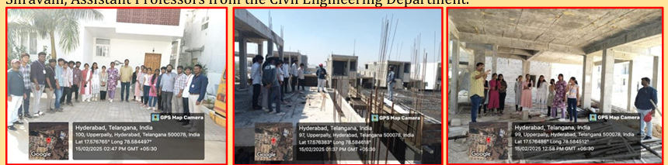
ii. Visited to “JSW Cements- RMC Plant”, Patancheru, Hyderabad on 24.02.2025.
An industrial visit was organized for II-II and III-II Civil Engineering students to JSW CEMENTS (RMC), Patancheruvu, where Mr. N. Narender, RMC Plant Manager, served as the expert speaker. With extensive experience in ready-mix concrete operations, Mr. Narender provided valuable insights into the functioning of the RMC plant. The visit aimed to bridge the gap between theoretical concepts and real-world applications. Students observed the entire cement production process—from raw materials like limestone, clay, and gypsum to the final product—while gaining knowledge of crucial quality control procedures such as fineness and compressive strength tests for cement, and moisture content and grading analysis for aggregates. A key highlight was the demonstration of the batching plant, where students learned how materials are precisely measured and uniformly mixed using advanced automation techniques to ensure consistent concrete quality. The session also emphasized environmental and safety practices adopted by the plant, including waste management, dust control, and energy efficiency. A total of 40 students participated in the visit, accompanied by two faculty members, Mr. G. Sampath Kumar and Ms. V. Navaneetha, both Assistant Professors in the Civil Engineering Department.
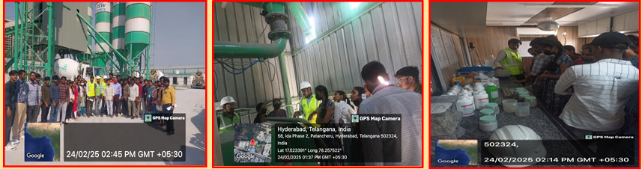

- Student participation &achievements

Academic Year 2024-2025

S. No. | H. No. | Name | Event Name with Date | Place
 | 24R11A0111 | O. Thilak Teja | Sports- Kho Kho  30.07.2024 | Pallavi Engineering
 | 24R11A0114 | R. Vedhanth (II Year) | Sports- Basketball  03.08.2024 | Srindihi Institute of Science and Technology
 | 24R11A0114 | P. Sravani (III Year) | Tech Samparthi- Cadathon  19.09.2024 | Nalla Narasimha Reddy Group of Institutions
 | 23R15A0101 | Ankith. M (III Year) | Tech Samparthi- Technical Quiz  19.09.2024 | Nalla Narasimha Reddy Group of Institutions

Bhaswara
Academic Year 2024-2025

The National Level Technical and Management fest was held on 15-04-2025 and 16-04-2025. The department of Civil Engineering has organized six events. The particulars of event are indicted below.

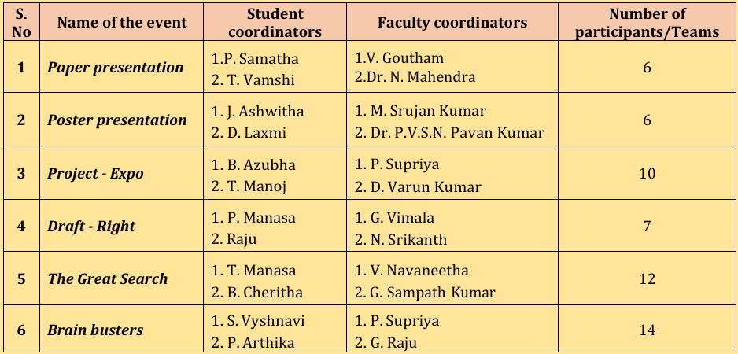
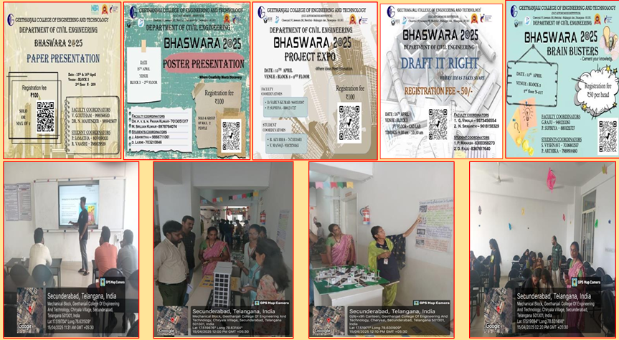

Freshers Day:
A.Y. 2024-2025
On September 13, 2024, the Civil and Mechanical Engineering departments of GCET jointly organized Fresher’s Day in the Block 3 Seminar Hall, extending a warm welcome to the newly admitted students. The event began with cordial addresses by the Heads of both departments, setting an enthusiastic tone for the evening. Senior students presented a lively lineup of games, cultural performances, and engaging activities, creating an atmosphere of joy and camaraderie. The freshers took the opportunity to introduce themselves and interact with both peers and seniors, fostering early connections. The celebration concluded with a vote of thanks and refreshments, leaving behind a memorable start to their journey at GCET.
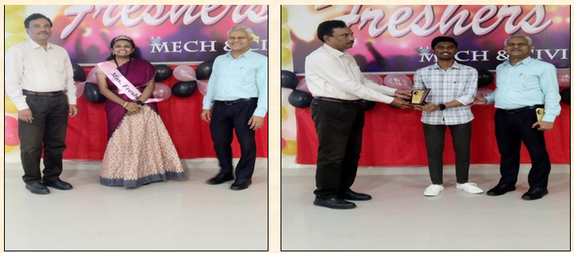

Placements (2021-2025 Batch)

S.  No | Roll  number | Name of the student | No. of  offers | Name of the Company | Package
1 | 21R11A0101 | Alluri Uttej Vadan | 1 | 1. Thermopads | 3.2 LPA
2 | 21R11A0102 | Angadi Praveen | 9 | 1. Inspire Leap | 6 LPA
 |  |  |  | 2. Procmart | 3.5 LPA
 |  |  |  | 3. MRF | 2.5 LPA
 |  |  |  | 4. Thermopads | 3.2 LPA
 |  |  |  | 5. Skill Intern | 5.2 LPA
 |  |  |  | 6. Knacktech | 3 LPA
 |  |  |  | 7. Teachnook | 3 LPA
 |  |  |  | 8. TVS Sundaram | 2.4 LPA
 |  |  |  | 9. Growth Arrow LTD | 5 LPA
3 | 21R11A0103 | B N Sai Santosh | 1 | MRF | 2.5 LPA
4 | 21R11A0104 | Babburi Pranay | 1 | SLN Buildcon | 2.16LPA
5 | 21R11A0106 | Bhukya Rajashekar | 1 | SLN Buildcon | 2.16LPA
6 | 21R11A0107 | Boda Rajesh Nayak | 1 | Skill Intern | 5.2 LPA
7 | 21R11A0111 | Dharavath Venkat | 6 | 1. Procmart | 3.5 LPA
 |  |  |  | 2. FLU Edtech Pvt Ltd | 4 LPA
 |  |  |  | 3. Talent Trek E Learning Pvt Ltd | 4 LAP
 |  |  |  | 4. Growth Arrow LTD | 5 LPA
 |  |  |  | 5. SLN Buildcon | 2.16LPA
 |  |  |  | 6. MEIL | 3LPA
8 | 21R11A0116 | Madde Chandra Shekar | 2 | 1. TVS Sundaram | 2.4 LPA
 |  |  |  | 2. Skill Intern | 5.2 LPA
9 | 21R11A0118 | N. Komal Nageshwarrao | 1 | MGH Infra Pvt Ltd | 6 LPA
10 | 22R15A0101 | Akkenapally Shreya | 1 | Shahgaron : Oracle ERP Solution | 1.8 LPA
11 | 22R15A0102 | A.Peddolla Mavitha | 3 | 1. Ctrl S - Data Centers India LTD | 4.0 LPA
 |  |  |  | 2. Skill Intern | 5.2 LPA
 |  |  |  | 3. Shahgaron : Oracle ERP Solution | 1.8 LPA
12 | 22R15A0103 | B Naveen Kumar | 2 | 1. Shahgaron : Oracle ERP Solution | 1.8 LPA
 |  |  |  | 2. SLN Buildcon | 2.16LPA
13 | 22R15A0105 | Bokka Dhana Shekar | 1 | Skill Intern | 5.2 LPA
14 | 22R15A0106 | Dappu Muralidharan | 1 | MEIL | 3LPA
15 | 22R15A0107 | Dastagiri Nithin Kumar | 3 | 1. MGH Infra Pvt Ltd | 6 LPA
 |  |  |  | 2. Shahgaron : Oracle ERP Solution | 1.8 LPA
 |  |  |  | 3. MEIL | 3LPA
16 | 22R15A0108 | K. Shiva Kumar | 4 | 1. Growth Arrow LTD | 5 LPA
 |  |  |  | 2. Nglome | 2.16 LPA
 |  |  |  | 3. Thermopads | 3.2 LPA
 |  |  |  | 4. SLN Buildcon | 2.16LPA
17 | 22R15A0109 | Kodam Nikhil | 3 | 1. Shahgaron : Oracle ERP Solution | 1.8 LPA
 |  |  |  | 2. MGH Infra Pvt Ltd | 6 LPA
 |  |  |  | 3. Kalpataru | 4.5LPA
18 | 22R15A0110 | Koneti Ephraim | 1 | MEIL | 3LPA
19 | 22R15A0111 | Koppula Pavan Kumar | 1 | KI TECH LTD | 5.20 LPA
20 | 22R15A0112 | Kunta Ganesh | 1 | Kalpataru | 4.5LPA
21 | 22R15A0114 | M. Kushalatha | 2 | 1. Launched | 5 LPA
 |  |  |  | 2. Nglome | 2.16 LPA
22 | 22R15A0115 | Porika Bhavana | 3 | 1. Nglome | 2.16 LPA
 |  |  |  | 2. Intelipaats Solutions | 9 LPA
 |  |  |  | 3. Launched | 5 LPA
23 | 22R15A0116 | Pudari Harikrishna | 2 | 1. SLN Buildcon | 2.16LPA
 |  |  |  | 2. MEIL | 3LPA
24 | 22R15A0117 | Ragula Hemanth | 1 | SLN Buildcon | 2.16LPA
25 | 22R15A0118 | R Praveen Kumar | 1 | Kalpataru | 4.5LPA
26 | 22R15A0120 | Viswakarma Dheeraj | 2 | 1. Shahgaron : Oracle ERP Solution | 1.8 LPA
 |  |  |  | 2. MEIL | 3.0LPA
27 | 22R15A0121 | Voggu Praveen | 1 | SLN Buildcon | 2.16LPA
28 | 22R15A0122 | Inampudi Nagababu | 1 | SLN Buildcon | 2.16LPA

